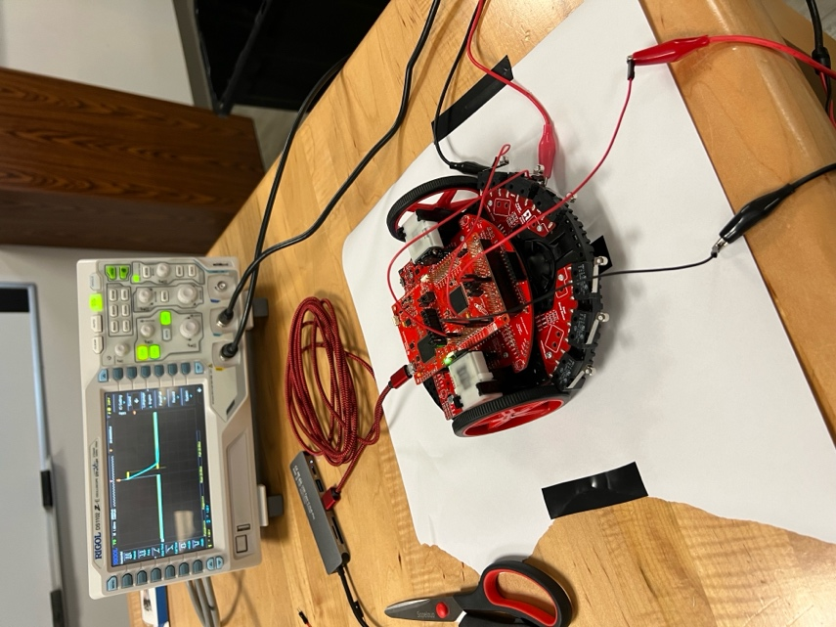

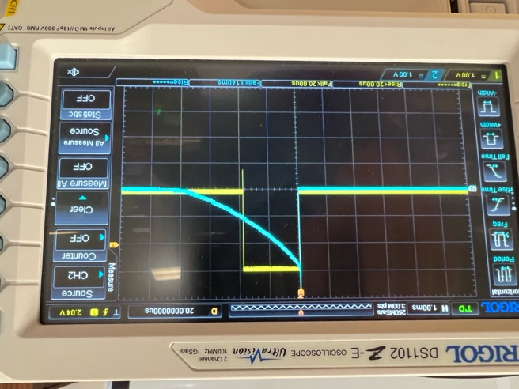 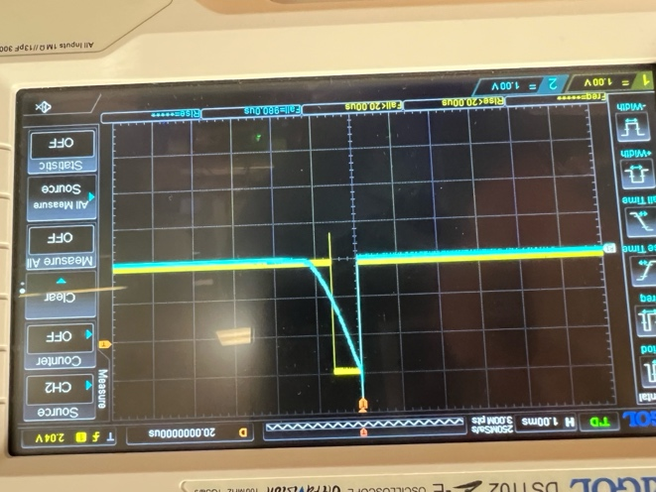

RC Time Contstants: 980us / 3.140ms

1. The time constants are different when the system is over a white surface vs black surface due to the time the capacitor is discharged.
2. 0V-1.2V
3. 1.2V-3.6V



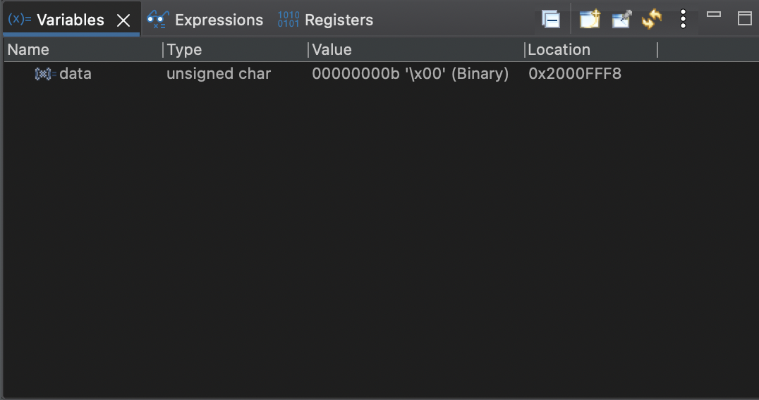 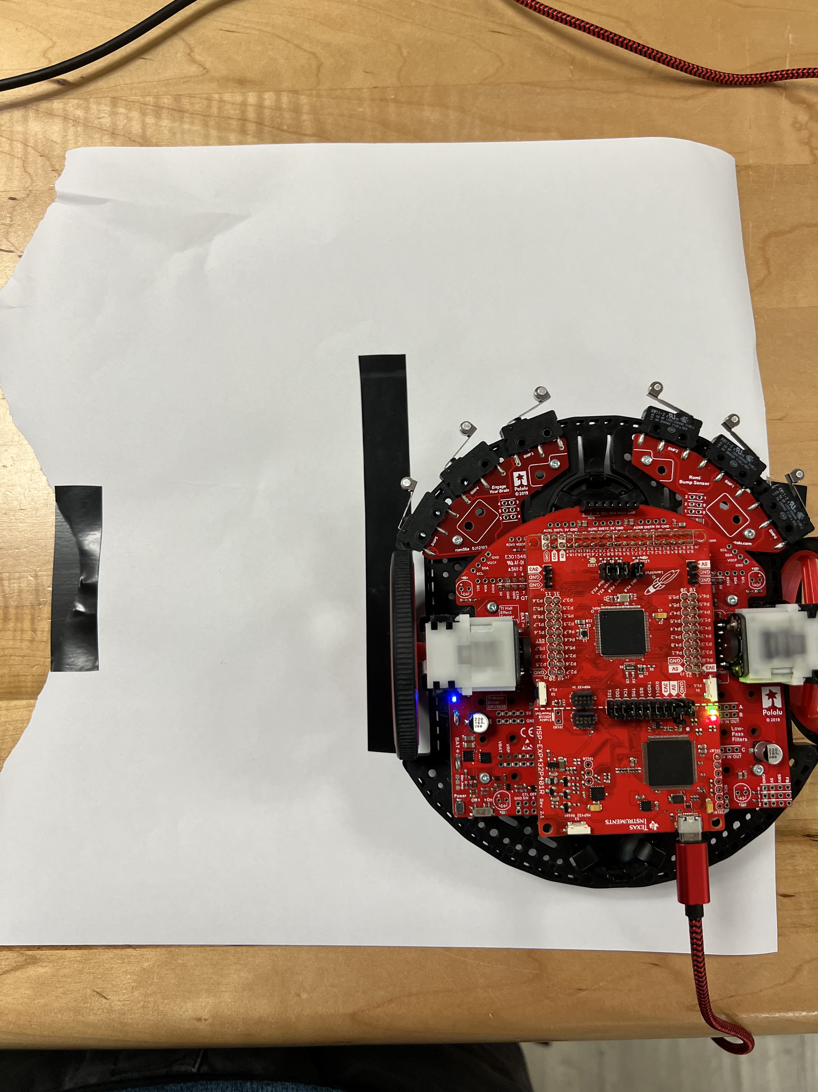

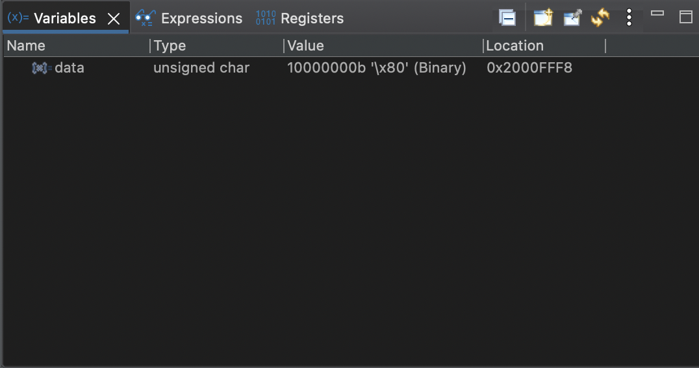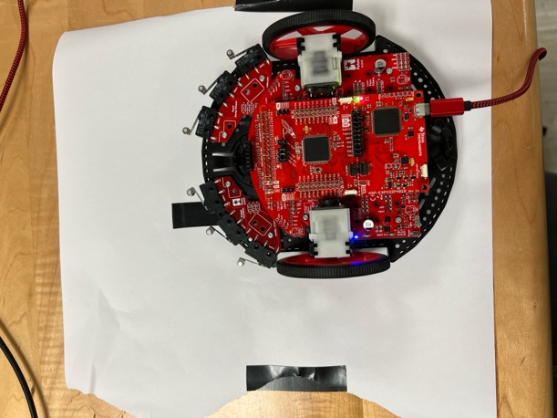

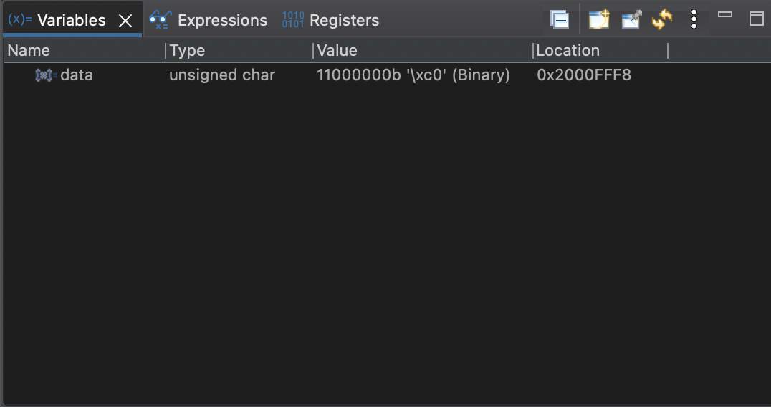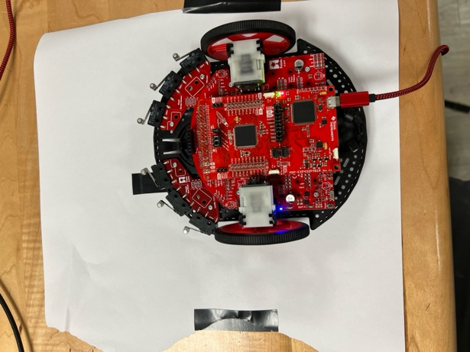

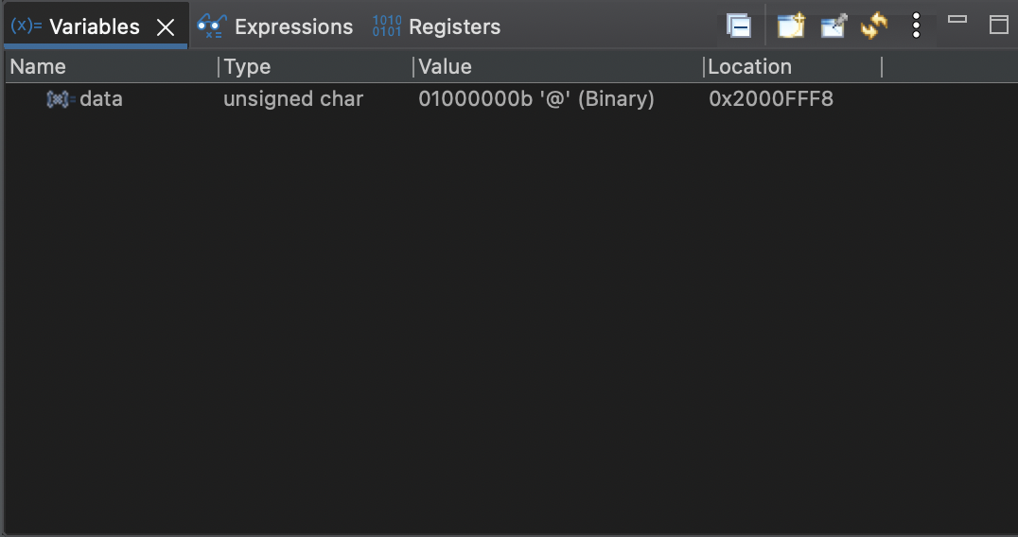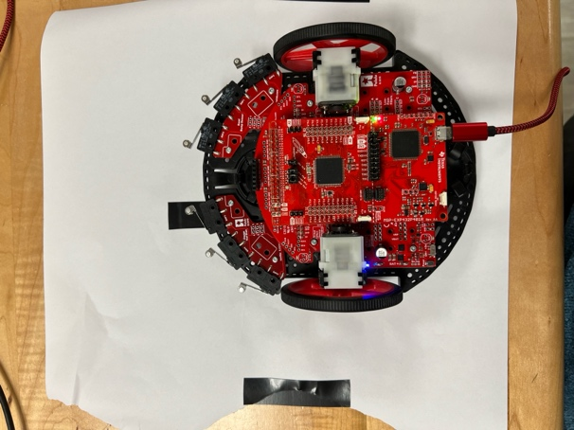

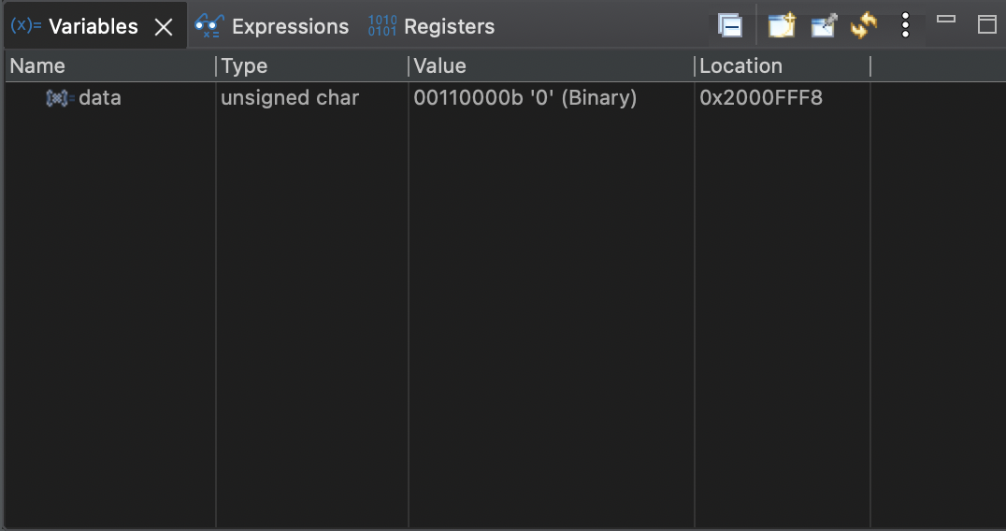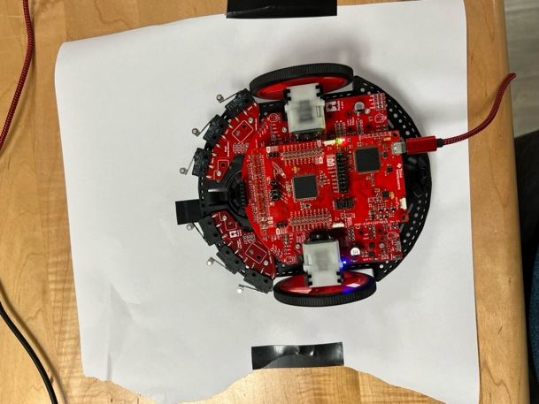



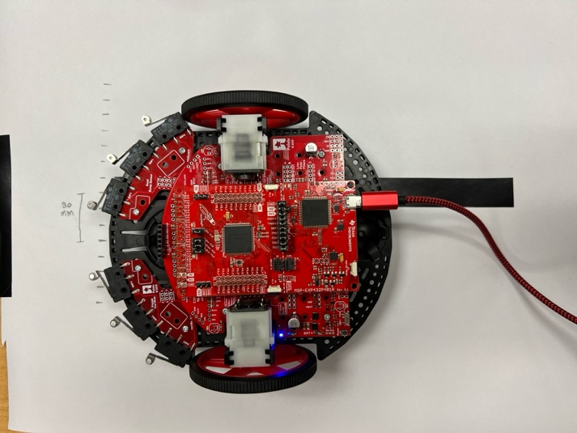

1. The accuracy from the line sensor is exactly what I expected, as the LEDs detect further left on the sensor array the more negative the values and vice versa as the sensor array detects towards the right.
2. The outputs from Reflectance_Position are monotonic due to the increasing nature of the graph. It is important for our application because you can take a measurement reading from the line sensor and directly correlate it to a distance/spot on the line sensor array.